PROJECT DOCUMENTATION
Implement Client Script and UI Policy for Incident
ServiceNow Incident Management / Client-side Configuration
Team ID | SWTID-2026-3243
Team Size | 4
Team Leader | SANDHIYA S
Team Member | VANISRI G
Team Member | AGALYA M
Team Member | DUVADHARSHINI M

Team E-Mail IDs
santhiya03112006@gmail.com
vanishal0207@gmail.com
dhuvadharshinim@gmail.com
agalyaatchaya45@gmail.com
Project Topic: Implement Client Script and UI Policy (Incident)

1. Introduction

1.1 Project Overview
Incident Management in ServiceNow is used to record, track, prioritize, and resolve incidents. Client Scripts and UI Policies are client-side configuration tools that improve the behavior of an Incident form without requiring changes to the server-side database logic.
This project demonstrates how a Client Script can perform form logic using JavaScript and how a UI Policy can control field behavior such as visibility, mandatory status, and read-only status. The configurations are applied to the Incident form.

1.2 Objective
- To understand the purpose of Client Scripts in ServiceNow.
- To create and configure a Client Script for the Incident table.
- To understand the purpose of UI Policies in controlling form fields.
- To create and configure a UI Policy for the Incident table.
- To test the configurations and verify the expected Incident form behavior

1.3 Project Outcome
The expected outcome is an Incident form in which client-side rules are automatically applied when the form loads, when a selected field value changes, or when the record is submitted. The UI Policy should dynamically control specified Incident fields according to the configured condition.

1.4 Technologies and Components Used
Component | Purpose
ServiceNow Incident | Provides the incident record and form used for configuration.
Client Script | Executes client-side JavaScript based on form events.
UI Policy | Controls field visibility, mandatory status, and read-only behavior.
UI Policy Action | Defines the field-level effect of a UI Policy.
JavaScript / Glide Form | Provides client-side form APIs used by Client Scripts.

2. Problem Statement and Proposed Solution

2.1 Problem Statement
Incident forms may contain fields that should behave differently depending on the incident data. If users must manually decide which fields are mandatory, visible, or editable, data entry can become inconsistent and important information may be missed.

2.2 Proposed Solution
The project uses a Client Script and a UI Policy on the Incident table. The Client Script provides event-based JavaScript behavior, while the UI Policy applies field-level form behavior when its condition becomes true.

2.3 Process Flow
- Open the Incident form in ServiceNow.
- Create the required Client Script for the Incident table.
- Select the appropriate Client Script type and define the script logic.
- Create a UI Policy for the Incident table.
- Define the UI Policy condition.
- Configure UI Policy Actions for the required fields.
- Save the configuration and test the Incident form.
- Verify that the fields and script behavior change as expected.

2.4 Scope
- Incident table and Incident form configuration.
- Client-side JavaScript using a Client Script.
- Field behavior using a UI Policy and UI Policy Actions.
- Basic functional testing on the Incident form.

2.5 Out of Scope
- Server-side Business Rules and Script Includes.
- External integrations and third-party systems.
- Advanced workflow or approval automation.
- Production deployment beyond the demonstrated configuration.

3. Implementation

3.1 Open the Incident Table Configuration
- Log in to the ServiceNow instance.
- Open the Application Navigator.
- Search for Client Scripts and open the Client Scripts module.
- Create a new Client Script.
- Set the Table to Incident.
- Enter a meaningful name and select the required Client Script type.

3.2 Client Script Types
Type | Use
onload | Runs when the Incident form loads.
on Change | Runs when a selected field value changes.
on Submit | Runs when the user submits the form.
on Cell Edit | Runs when a list cell is edited, where applicable.

3.3 Example Client Script Configuration
For the project demonstration, an on Change Client Script can be configured on an Incident field such as Category. When the field value changes, the script can update another form field using the Glide Form API. The exact field and logic should match the configuration used in the student's ServiceNow instance.
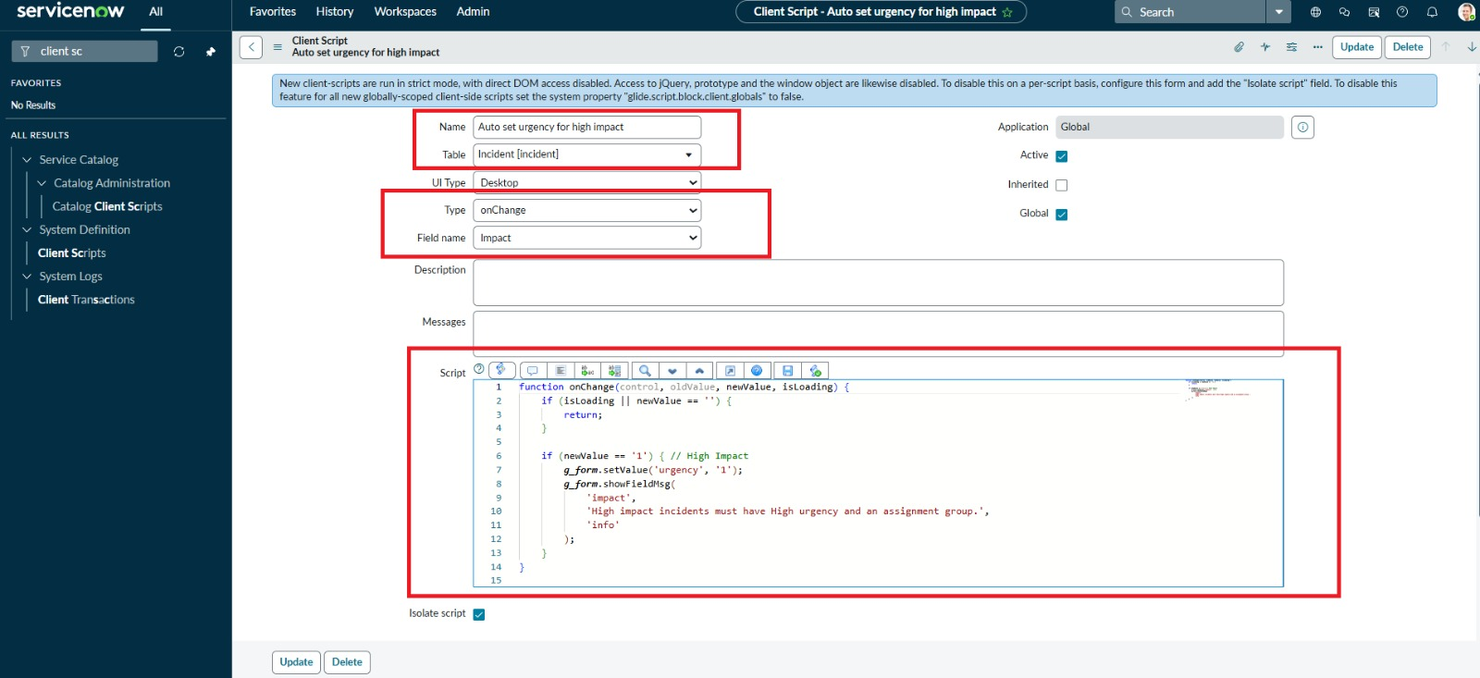

Figure 1. Client Script – New/Configured Record

3.4 Client Script Logic
A Client Script contains JavaScript that executes in the user's browser. In ServiceNow, the Glide Form object is commonly used to read and change values or properties on the current form.
Example logic for an On Change Client Script:
function on Change(control, Old Value, new Value, is Loading, is Template) {
if (is Loading || new Value == '') {
return;
}
// Example: update a field based on the selected value.
// Replace the field names and values with your project configuration.
if (new Value == 'software') {
g_form.setMandatory('description', true);
}
}
Note: The example is a demonstration of Client Script syntax. The actual field names and condition should be adapted to the fields available in the Incident form used for the project.

3.5 Save and Test the Client Script
- Save or update the Client Script.
- Open a new or existing Incident record.
- Change the configured field value.
- Observe the expected client-side behavior.
- Repeat the test with another value to confirm the condition.
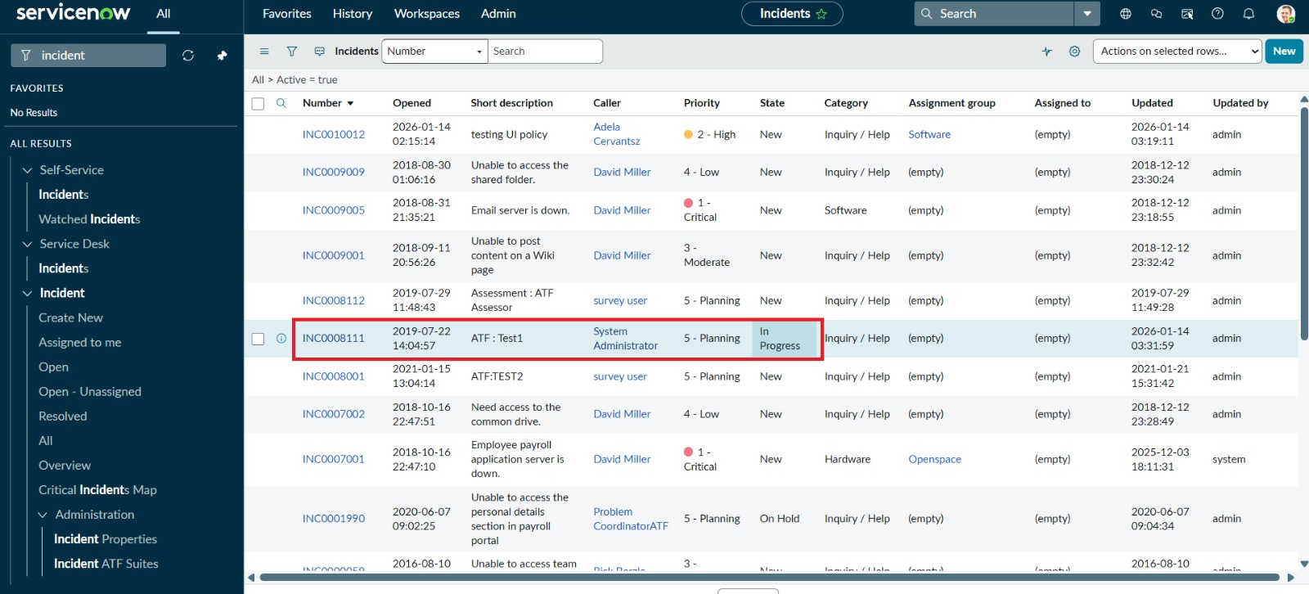

Figure 2. Incident Form – Client Script Test

3.6 Create the UI Policy
- Open the Application Navigator.
- Search for UI Policies and open the UI Policies module.
- Create a new UI Policy.
- Set the Table to Incident.
- Enter a meaningful short description.
- Define the condition that should activate the policy.
- Save the UI Policy.

3.7 UI Policy Example
A simple Incident example is to apply a policy when an Incident reaches a particular state. For example, a UI Policy may make a resolution-related field mandatory when the Incident is being resolved. The exact condition should be based on the configuration demonstrated in the project.

3.8 UI Policy Actions
UI Policy Actions specify what happens to individual fields when the policy condition is true. Common controls include Mandatory, Visible, and Disabled/Read-only behavior .
Field behavior | Purpose | Example
Mandatory | Requires a value before submission. | Resolution notes
Visible | Shows or hides a field. | A supporting field
Disabled / Read-only | Prevents editing while the condition applies. | A system-controlled field
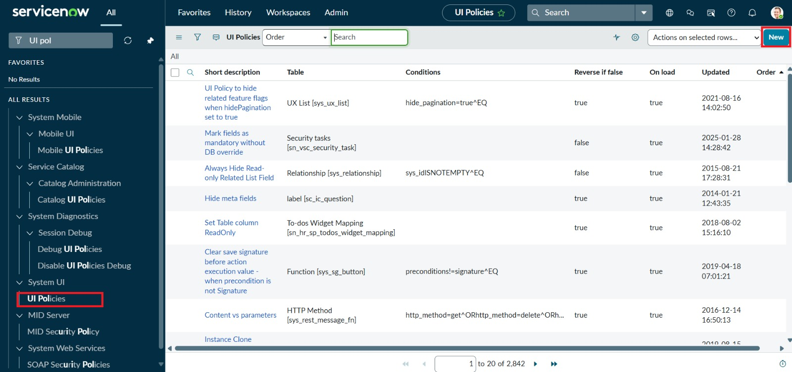

Figure 3. UI Policy – Configured Condition

3.9 Configure UI Policy Actions
- Open the UI Policy created for the Incident table.
- Scroll to the UI Policy Actions related list.
- Click New to create a field action.
- Select the required Incident field.
- Set the required behavior such as Mandatory, Visible, or Disabled.
- Save the UI Policy Action.
- Add additional actions if more than one field must be controlled.

3.10 Reverse if False
When appropriate, the UI Policy can reverse the field changes when its condition is no longer true. This helps the form return to its normal state when the Incident values change.

3.11 Client Script and UI Policy Together
The two configurations serve different purposes. The Client Script is used when custom JavaScript logic is needed for a form event. The UI Policy is intended for declarative field behavior based on a condition. Using the suitable tool for each requirement keeps the Incident form easier to maintain.
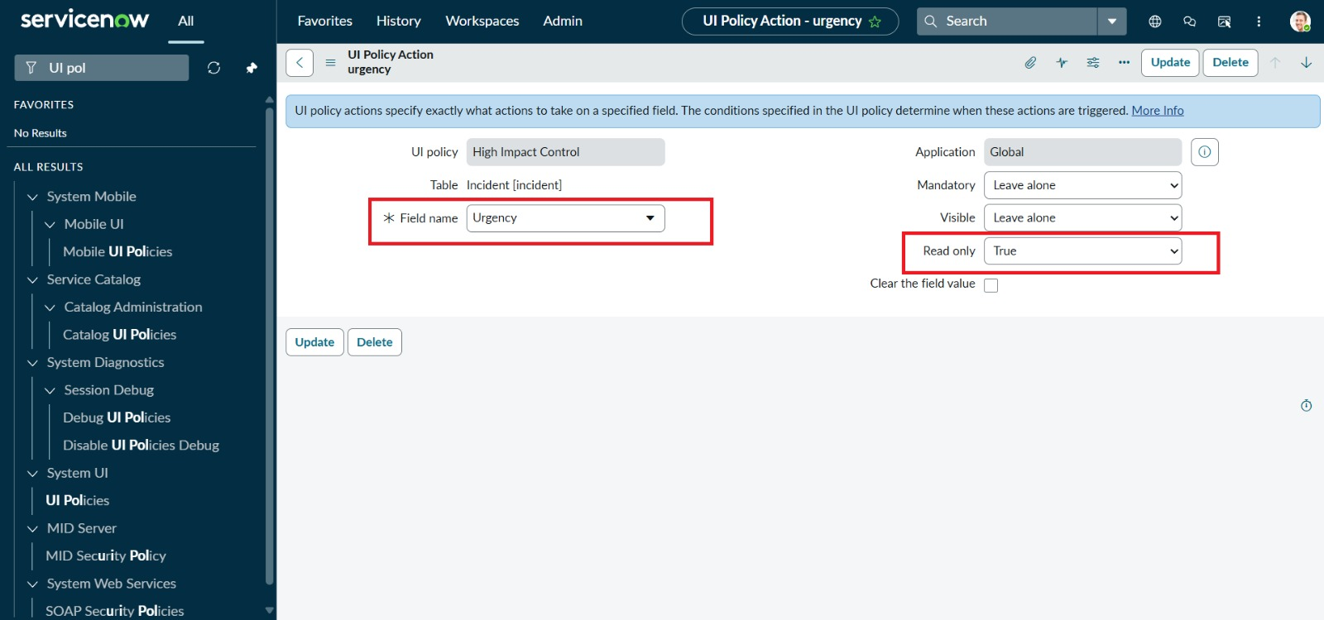

Figure 4. UI Policy Action – Field Behavior

3.12 Final Incident Form Test
- Open the Incident list and create a new Incident.
- Enter the required basic incident information.
- Trigger the condition configured in the UI Policy.
- Verify that the configured field behavior changes correctly.
- Trigger the Client Script event, if applicable.
- Verify the Client Script result.
- Submit or update the Incident and confirm that the form accepts the record when all required conditions are satisfied.

3.13 Expected Result
The Incident form should respond automatically to the configured conditions. The Client Script should execute its JavaScript logic at the selected event, and the UI Policy should apply the configured field actions when its condition is true.
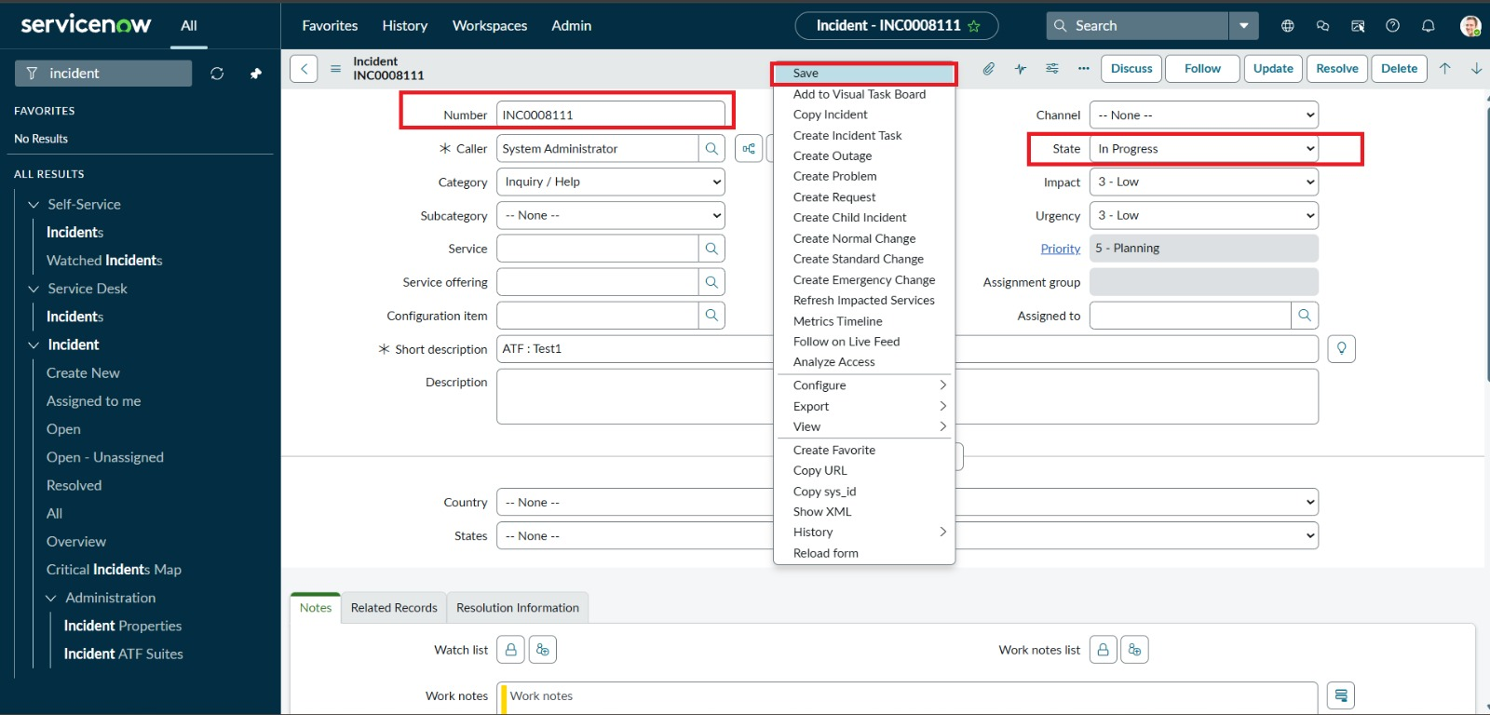

Figure 5. Incident Form – Final Expected Behavior

4. Testing and Validation

4.1 Test Cases
Test | Expected | Observed | Status
T1 Client Script configuration | Client Script exists for Incident with the selected type/event. | To be filled from PDI screenshot | Pass/Update
T2 Client Script execution | Configured script runs when its event occurs. | To be filled from PDI screenshot | Pass/Update
T3 UI Policy condition | Policy becomes active when the condition is true. | To be filled from PDI screenshot | Pass/Update
T4 UI Policy Action | Configured field becomes mandatory/visible/disabled as intended. | To be filled from PDI screenshot | Pass/Update
T5 Form submission | Incident can be submitted after required values are provided. | To be filled from PDI screenshot | Pass/Update
The 'Observed' and 'Status' columns should be updated after testing the configuration in the ServiceNow instance.

5. Benefits, Limitations and Future Enhancements

5.1 Benefits
- Improves consistency of Incident form data entry.
- Reduces unnecessary manual checks by users.
- Provides dynamic form behavior based on Incident values.
- Helps ensure important information is collected when required.
- Makes the Incident form easier to use and maintain when rules are clearly configured.

5.2 Limitations
- Client Scripts mainly affect the client-side form experience.
- UI Policies are primarily intended for form field behavior.
- The exact result depends on the Incident fields and conditions configured in the instance.
- The demonstrated project does not cover server-side validation, integrations, or advanced automation.

5.3 Future Enhancements
- Add server-side validation where business rules require it.
- Add notifications or workflow automation for important Incident states.
- Create additional UI Policies for different Incident categories or states.
- Improve validation using suitable Client Script events.
- Extend the Incident process with reporting and service-level monitoring.

6. Conclusion
This project demonstrates the implementation of Client Script and UI Policy on the ServiceNow Incident table. The Client Script provides event-based client-side logic, while the UI Policy controls field behavior according to a defined condition. Together, these configurations can make Incident data entry more consistent and user-friendly.
The project also provides practical experience in navigating ServiceNow configuration modules, creating client-side rules, configuring field actions, and validating the final behavior through Incident form testing.

7. Key Learnings
- Understanding the purpose of Client Scripts in ServiceNow.
- Understanding common Client Script types and form events.
- Using Glide Form APIs for client-side form behavior.
- Understanding UI Policies and UI Policy Actions.
- Configuring mandatory, visible, and disabled/read-only field behavior.
- Testing client-side configurations on the Incident form.

Appendix A – Demonstrated Configuration Summary
Configuration Item | Project Value
Table | Incident
Configuration 1 | Client Script
Client Script Type | Use the type selected in the PDI
Configuration 2 | UI Policy
UI Policy Condition | Use the condition configured in the PDI
UI Policy Action | Mandatory / Visible / Disabled as configured
Testing | Incident form functional testing

Appendix B – Screenshot Checklist
- Client Script list/new record screen.
- Client Script configuration and script field.
- Incident form showing Client Script result.
- UI Policy configuration screen.
- UI Policy Action screen.
- Final Incident form showing the UI Policy result.

Note: Because the Personal Developer Instance is currently waitlisted, the screenshot placeholders above can be replaced with the actual ServiceNow screenshots after the instance becomes available.

